Congressional plans differ in Capital Region treatment
By Jimmy Vielkind, Capitol bureau in Redistricting

Posted on March 1, 2012 at 10:55 am
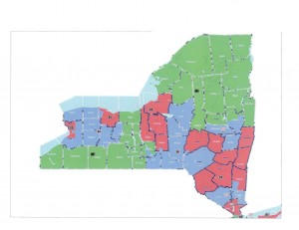
The Assembly Republicans’ plan.
Three proposed sets of congressional districts submitted by lawmakers treat the Capital Region very differently, splitting up the tri-cities between two representatives.

The submissions were made last night in response to a federal court order. U.S. Magistrate Roanne Mann will consider the legislative proposals, others submitted by good-government groups as well as testimony at a public hearing Monday afternoon. She will develop a plan by March 12. Mann was given the redistricting pen when a three-judge panel ruled Monday that LATFOR, a legislative task force jointly controlled by Democrats who dominate the Assembly and Republicans with a bare majority in the Senate, had reached impasse.

In their proposal, Assembly Republicans combined Montgomery, Schenectady, Albany and most of Saratoga County into a single district. It’s impossible to know without seeing the exact demographics, but it would seem to be more balanced between enrolled Democrats and Republicans than the current district, which includes Albany and Schenectady counties, the urbanized core of Rensselaer County as well as Schoharie, Fulton and Montgomery counties. It is currently held by Rep. Paul Tonko, D-Amsterdam.

The Assembly Republicans straddled that district with a Hudson Valley seat that includes most of Otsego County, Schoharie, Rensselaer, Greene, Columbia, Ulster, Sullivan and most of Dutchess County. Rep. Chris Gibson, R-Kinderhook, currently represents a Hudson Valley seat that curves around Albany and includes Columbia, Greene and parts of Dutchess County, most of Rensselaer County, then Saratoga, Warren, Washington and most of Essex County. The Assembly Republican plan expands an “Adirondack District” now represented by Rep. Bill Owens, D-Plattsburgh, into Warren and Washington counties.

The Senate Republicans' plan.
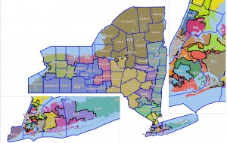
The Senate Republican’s plan.

Senate Republicans proposed a district of Montgomery, Schenectady, Albany and Ulster counties, that also includes a small slice of Greene County. It largely mirrors a 63rd state Senate district they proposed, which sources say was envisioned for Assemblyman George Amedore, R-Rotterdam. He is personally wealthy as the founder of a home-building company.

Gibson’s district doesn’t change much under the plan, but drops Essex County and gains parts of Ulster and Sullivan counties.

Assembly Democrats also move Tonko into Saratoga County, but slice it to remove the Republican-rich towns of Clifton Park and Halfmoon from his area but pick up Saratoga Springs. Those Republican areas of Southern Saratoga County would remain in Gibson’s district, which would be re-worked to stretch as far south into Orange County.

Warren and Essex counties would be lumped into a district stretching diagonally across the state to…Broome County. That’s right: from Binghamton to Elizabethtown in one district. Because when I think Binghamton, I immediately think to myself, “yes, and the second-largest city in the district that contains Binghamton should be Glens Falls.”

AD-105
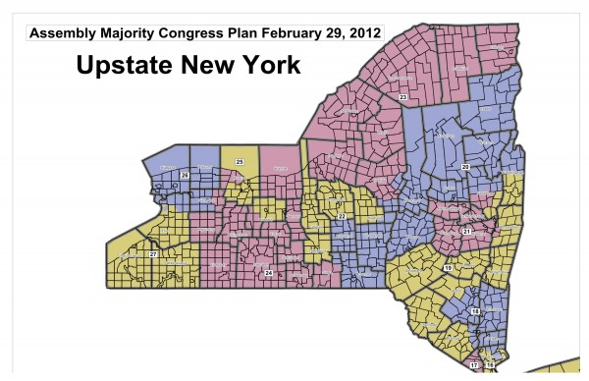
The Assembly Democrats’ plan

